Books by Rajesh Joshi Ji
Contents
1. Hinduism Basics for All 1
2. Hinduism and Science 2
3. Diwali - The Oldest Festival on The Planet 4
4. Navaratri: Science and The Bhakti of Shakti 7
5. eYogi Yoga and Meditation Guide 9
6. Leaving Cert Guide 11

Hinduism Basics for All
An Introduction to Hindu Scriptures, Basic Mantras, Hinduism History, Moral Stories, Frequently Asked Questions and their Scientific Answers
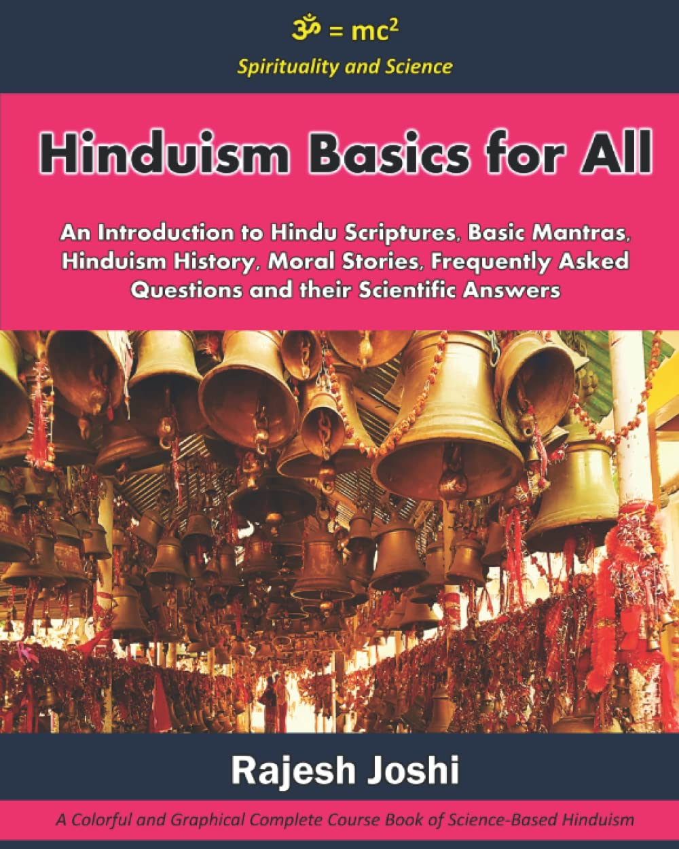
Hinduism is the oldest living religion on this planet, with its roots going back 15,000 years and more. It has one billion followers, and every 7th person on this planet is a Hindu. Hinduism is not only a religion but also a "Way of life." The word “Hindu” is a geographical name for the people who lived beyond the Sindhu River and between the Himalayan Mountains and the Indus Sea. Over time mispronouncing Sindhu became Hindu.
While the rest of the world is trying to find happiness using materialistic means and looking outward, Hinduism from the east believes happiness is an inner experience and provides means to achieve with self-exploration or looking inward. Yoga and Meditation techniques are an example of this, helping millions of people overcome stress, anxiety, depression, and other mind-related diseases.
Hinduism is a science-based religion. All rituals and traditions of Ancient India have deep science behind them. In this book, I have attempted to explore science and spirituality and produced the basics of Hinduism. This book is for all those who want to learn about the basics of Hinduism. I have made this book very different from traditional ones with black-and-white text only. This book uses a presentation style color format to provide a simple and to-the-point explanation of the following:
- Hinduism and its History
- Core Scriptures of Hinduism
- Frequently Asked Questions and Answers about Hinduism
- Daily Mantras for Daily Chanting
- Commonly used Morale stories.
This book is a colourful and graphical style and a complete Course Book on Science-Based Hinduism. This book is developed as a coursebook for students to learn about Hinduism and is currently used for teaching.

Hinduism and Science
An Introduction to Science of Hinduism, Bhagavad Gita, Hindu School of Philosophies, Yoga, Meditation, Vedanta, Mantras and their Scientific Answers and Morale Stories
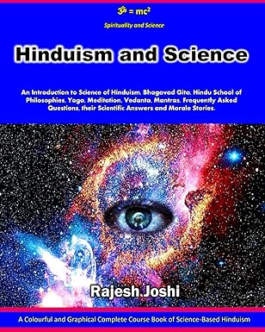
Hinduism is the oldest living religion on this planet, with its roots going back 15,000 years and more. It has one billion followers, and every 7th person on this planet is a Hindu. Hinduism is not only a religion but also a "Way of life.“ Hinduism is a collection of philosophical and religious traditions based on the eternal laws of nature developed by various Rishis, Munis, and Yogi native to the Indian subcontinent. Hinduism has thousands of Rishis, Munis, and Yogis who have written over 10 million scripts in the last 10,000 plus years.
Science and logic are the foundations of Hinduism. As with science, Hinduism also encourages you to question everything. Hindu scriptures are usually based on questions asked to learned people. Throughout Hindu scriptures, questions are asked about various aspects of life and the universe between two or more individuals.
The sages of Hinduism have explored the possibilities of the human mind and examined all facets of life. The last 10,000 years have produced more than 10 million scriptures documenting these learnings. Only Hinduism has the largest collection of scriptures written before the 19th century. The Takshilla (तक्षशिला ) and Nalanda (नालंदा ) were the two oldest and largest universities set up and existed in India.
One of the highest virtues of Hinduism is knowing thyself. In India, a knowledge-based culture flourished, and families, the smallest unit of social life, embraced it. The most important thing for Indian mothers and fathers is that their children receive the best education possible. Since Hindus place a high value on knowledge, they have mastered various fields of modern life. Today, Indians hold the most important positions in the corporate world and are involved in significant discoveries. As a result of this culture of embracing knowledge in life, they produce peaceful solutions and logic-based rationale behind everything we do. In contrast to some other cultures claiming superiority and using violence, Hinduism promotes peace and coexistence.
While the west is trying to find happiness using materialistic means and looking outward, Hinduism from the east believes happiness is an inner experience and provides means to achieve it with self-exploration or looking inward. Yoga and Meditation techniques are an example of this, helping millions of people overcome stress, anxiety, depression, and other mind-related problems.
Most of the rituals and traditions of Ancient India have deep science behind them. This book explores the science and spirituality of Hinduism. This book contains the following;
- Hinduism and Science
- Bhagavad Gita and School of Hindu Philosophies
- Yoga, Meditation and Vedanta
- Vedic Mantras
- Frequently Asked Questions and Answers about Hinduism
- Naitik Shiksha – Moral Stories

Diwali - The Oldest Festival on The Planet
Rama the Ideal Man - A Short Book for Speakers
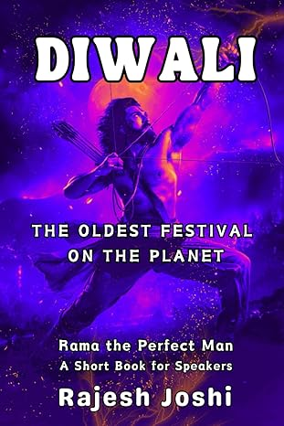

About the Book
This concise book aims to underscore the profound significance of the Ramayana for its readers, particularly those who are preparing to deliver a public speech on Diwali and the character of Rama. Crafted to facilitate a 30-minute speech, this brief guide is designed to provide essential insights into the subject matter.
What is Diwali?
On the day of Diwali, one of the primary deities of Hinduism, Lord Rama, returned to his kingdom after defeating the evil king Ravana, who kidnapped his wife. Rama is the ideal man who walked on this planet, demonstrating the highest virtue of life as a human who always upheld righteousness or Dharma. Life tested him in nearly all extremely harsh circumstances, but he remained calm, kind, brave, and upholding human values.
Rama - The Ideal Man - Maryada Purushottama
Lord Rama emerges as the embodiment of perfection in various roles—be it as an Ideal man, Ideal Son, Ideal husband, Ideal brother, Ideal friend, Ideal Enemy, Ideal Political Leader, Ideal Strategist, Ideal Architect, and Ideal King. His courage and resilience shine through as he faces life's challenges, always exemplifying the highest virtues while navigating trials as a mortal, not relying on divine interventions. A symbol of the triumph of good over evil, Rama's life teaches the importance of fulfilling moral commitments with nobility and humility. Despite facing numerous adversities, he remained resolute, embodying the principles of truth and righteousness. His life story, the Ramayana epic, is a marvel of human history.
Ramayana has surpassed all indexes of popularity for thousands of years. The celebration of Diwali symbolises his commitment and serves as a reminder to face challenges with courage for the greater good—whether for family, culture, religion, or Dharma—ultimately illustrating the enduring legacy of Lord Rama.
Book Index
Chapter 1 What is Diwali
Chapter 2 Ramayana
Chapter 3 Cultural Influence of Ramayana
Chapter 4 Ramayana Versions across the globe
Chapter 5 Why Lord Rama is Relevant Today

Navaratri: Science and The Bhakti of Shakti
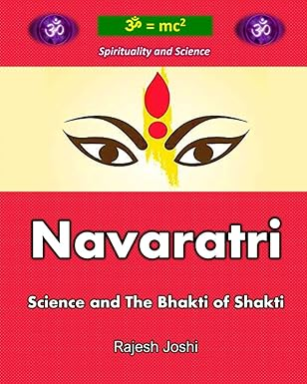
Hinduism is a science-based religion. All rituals and traditions of Ancient India have deep science behind them. The tradition of Navaratri also has a scientific and spiritual background. In this book, I have attempted to explore the science and spirituality of Navaratri. I have also provided a complete guide on how to worship the Divine Mother, Goddess Shakti.
This book is a presentation style format to provide simple and to-the-point explanations.
Navaratri is a widespread festival in India. It is celebrated across entire Indian states.
“Nav” means 9, “Ra” = that gives Solace, “Tri” = 3 types of Solace. Navaratri or 9 nights when one seeks Solace from all sufferings and gets rejuvenated. Apart from its spiritual significance, Navaratri has profound science behind it.
Most people do not know that there are 4 Navaratris, which are aligned with four seasonal changes. Flu seasons naturally occur when the weather transitions. Two major weather pattern changes are observed in a year.
From winter to summer: Mostly occurs in the months of Spring (Mach-April)
From summer to winter: Mostly occurs in the months of Autumn (Sep-Oct).
- Maagh Navarati - January – February
- Vasant Navaratri – March - April
- Ashad Navaratri - June - July
- Sharad Navaratri – September - October
As per science, when weather changes following is required:
- Food habit change - Winter and Summer seasons have food habits, so a change in food habits is required when seasonal change occurs.
- Detoxification of the body for 7 to 10 days
- Hygiene – Maintain a high level of hygiene. Navaratri has the following practices which satisfy the above scientific requirements.
  - Simple, less spicy and vegetarian food is eaten during the Navaratri period.
  - More water, juices, and other liquids are consumed, which help in detoxification of the body from the previous weather season.
  - Before prayers, one takes a bath. One to two prayers means 1-2 baths/day, morning and evening. To offer Bhog (first offering of food to a deity), one must prepare it by taking a bath, cleaning the house, kitchen, and all utensils. No one is allowed to touch the food until the offering is complete. So very high standards of hygiene are practised during Navaratri. So, Navaratri, in essence, is preparing ourselves for the seasonal change to help our body to adopt the new season.
Navaratri is the tale of the story of Durga, a fierce form of the Divine Mother who rides a lion and conquers the evil Mahisasura. In Hinduism, the concept of a divine feminine aspect of God can be traced back as far as any written texts and human memory exist. The first text of humanity and Hinduism, called Vedas, contains several aspects of the divine forces of the universe. Ramayana contains prayers of divine mother and Shakti. The tenth day of Sharad Navaratri is known as Vijayadashami or Dussehra, where Ram defeated and killed the evil king Ravana. Mahabharat contains prayers of divine mother and Shakti. Several Puran texts fully detail the mother Goddess and praying for Shakti. Markandeya Purana, from Chapter 81 to Chapter 93, is the most influential text of Shaktism. The 700 slokas (verses) of 13 chapters are called Durga Saptashati, Chandi Path, and Devi Mahatyamam. The Puranas originate in oral traditions where stories have been told generations after generations, so the roots of Durga Saptasati go back thousands of years.
Shiva and Shakti: In the Shakta philosophy, Shiva is never changing, eternal, pure consciousness. Shakti is his energy or kinetic power. The universe is a manifestation of this energy. Shiva is the omnipresent and inactive element, the pure consciousness. Meanwhile, Shakti is dynamic. Creation is not possible without both. Hence, they are one.

eYogi Yoga and Meditation Guide
A Beginner's Guide to Yoga and Meditation
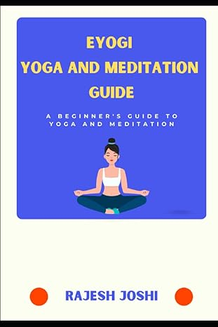
Yoga is a spiritual discipline based on a very subtle science. Yoga is believed to have originated with the dawn of civilisation. The method of Yoga came as an oral tradition, and writings were done much later. The science of yoga originated long before the first religions or belief systems were born on this planet. Shiva is seen as the first yogi, Adiyogi, and the first guru, Adi Guru, in yogic lore.
Yoga is a holistic practice integrating physical movements, breathing exercises, and meditation to promote overall health, well-being and mind control. It has been widely studied and shown to have numerous benefits for both physical and mental health. There have been hundreds of research papers published across the globe proving its benefit to human health. Thousands of Gurus have mastered Yoga in human history and written thousands of Yogic texts. Even today, hundreds of Yoga Gurus are teaching their style of Yoga worldwide in thousands of Yoga Centres. It is often hard to find a book that gives you a brief and complete guide to Yogic science, Yoga history, various forms of Yoga and a clear guide referencing an authentic text and authentic Guru.
The author has attended and studied various Yoga and Meditation programs like Vipassana, Tibetan Buddist meditation, Isha Kriya, Sudarshan Kriya, Raj Yoga of Brahmakumari, Patanjali Ashtanga Yoga and others. The author realised that one could easily be lost in the ocean of knowledge and various forms of Yoga and Gurus available today. A beginner needs some basic info before they choose a Guru or form of Yoga. This guide helps beginners in that sense. This quick guide focuses on the following.
- What is Yoga
- Yoga in Hindu Scriptures like Vedas, Upanishads, Itihasa (Ramayana and Mahabharat), Bhagavad Gita, Puran etc.
- Yoga in Indus Valley Civilization.
- A timeline history of Yogic Science development in the last 10,000 years
- Overview of ancient books on Yoga
- Patanjali Ashtanga Yoga
- Hatha Yoga technique
- Asana (Body postures), Pranayama (Breathing control), Kumbhak (Retention), Mudra (Gestures), and Bandha (Locks)
- Overview of Classical Yoga Before the 19th Century (Karma Yoga, Bhakti Yoga, Jnana Yoga, Raja Yoga, Hatha Yoga, Laya Yoga, Japa Yoga, Kriya Yoga, and Tantra Yoga)
- Modern Yoga 19th Century onwards (Vinyasa Yoga, Sivananda Yoga, Transcendental Meditation, Iyengar Yoga, Inner Engineering, Sudarshan Kriya Yoga, Brahma Kumaris Raja Yoga, Bikram Yoga, Power Yoga)
- How to Choose a Technique for Yoga
- eYogi Meditation Technique

Leaving Cert Guide
625 Days of Sthitprajna to Achieve 625 Points A Complete Guide to Leaving Cert Students and Parents
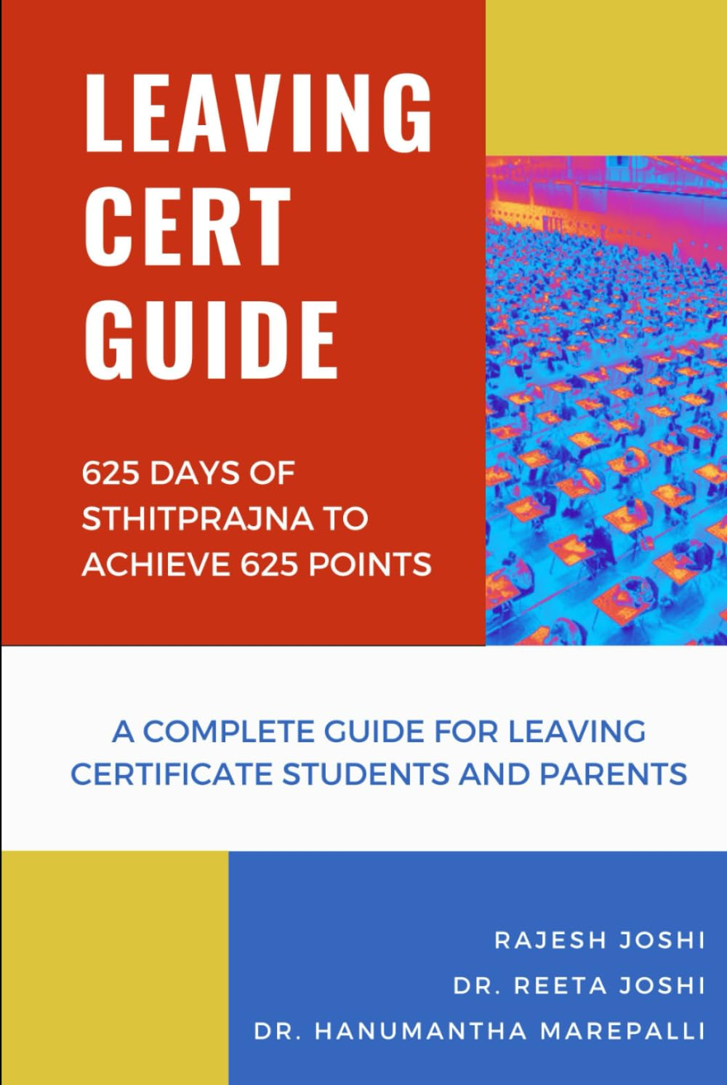

The authors of this book have experienced many challenges while preparing their kids for the Leaving Certificate and admissions to medicine in Ireland, the UK and Europe. They realised that most parents and students go through a painful process due to a lack of information and awareness for Leaving certification examinations and admission to medicine. The authors realise many parents in society need help to motivate their kids to prepare well for the leaving cert exams and guide them for college courses. They also felt many students could qualify for better courses and college based on their intellectual abilities. Still, due to lack of guidance to prepare for leaving cert, they suffer in their academic career, significantly impacting their personal life. They feel let down by their circumstances and regret the consequences. To support our students and parents, the authors decided to capture their learnings and experiences in a structured format, and this book came into existence. The purpose of this book is to provide a guide to all parents and students in the following three areas;
- Leaving Certificate Examination – a complete overview
- Admission to Medicine
- Sthitprajna – a Complete guide for Leaving Certificate Examination and Medicine Entrance Tests

